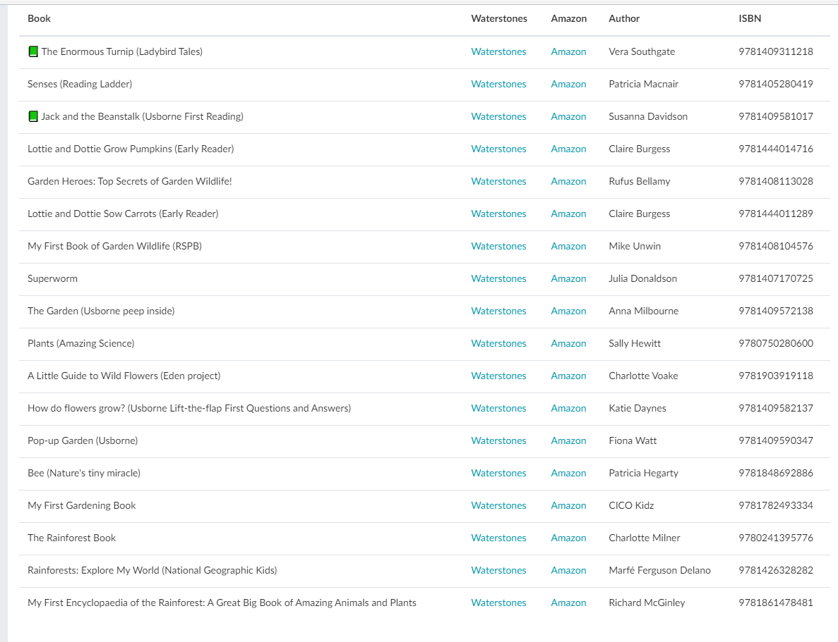
Scented Garden Recommended Book List – Spring Term 2

