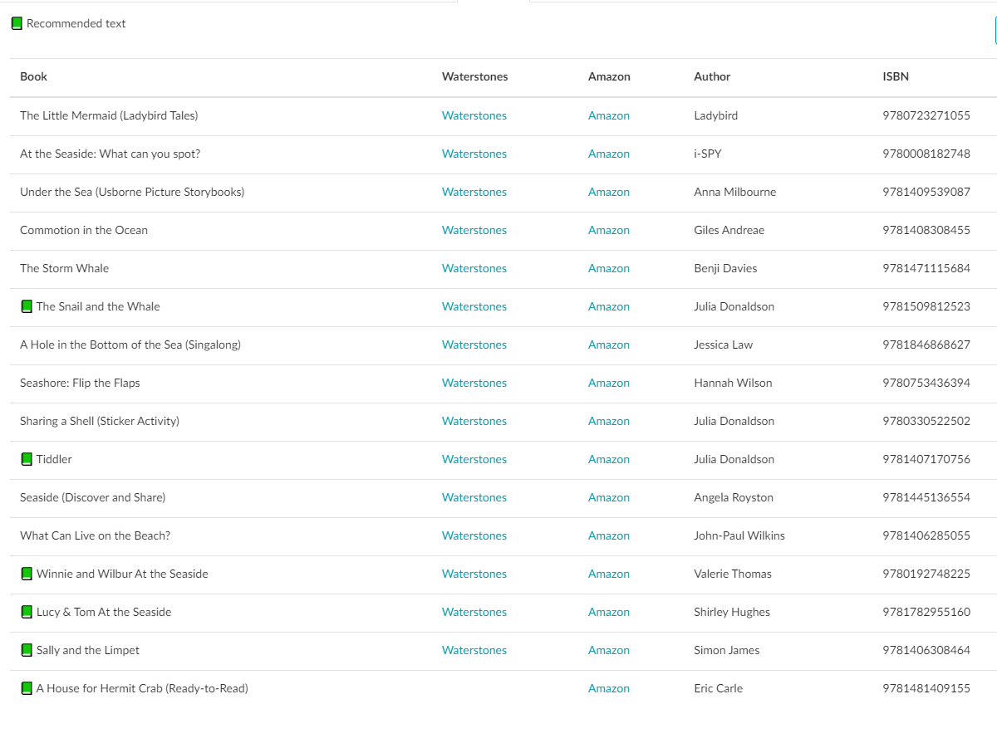
Y2 Recommended Book List to support the topic in Autumn Term 1:

